Career Coach

Job Description and Personal Specification

January 2023

Career Coach (Transitions)
Key information
- Permanent role
- Deadline for applications: 10/02/2023 by 12pm
- Apply at www.renaisi.com

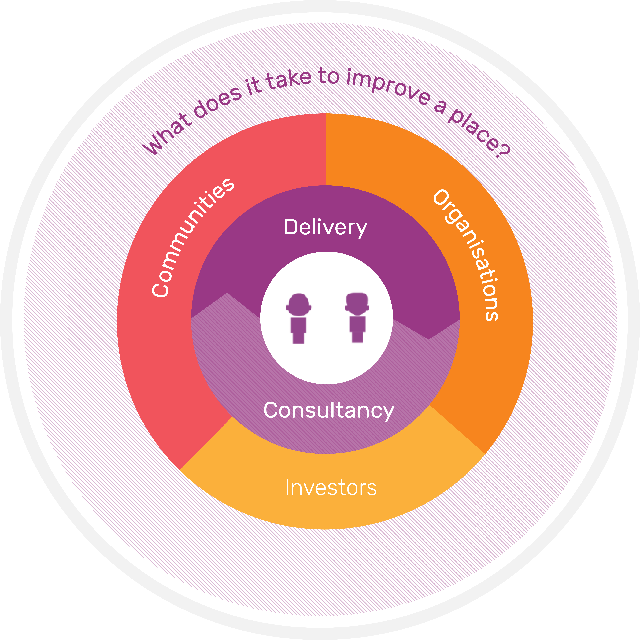
About Renaisi
Our mission is to create the conditions for strong, inclusive communities to thrive by doing three complementary things:
- Supporting people to learn, work and connect with their community.
- Helping organisations across the UK to understand their impact on communities.
- Exploring the question: what does it take to improve a place?
Renaisi is unique as we combine consultancy work with frontline service delivery. We're constantly learning from the different perspectives we see from working directly with communities, and from supporting social organisations, charities and institutions to deliver greater impact. This makes Renaisi a uniquely well-rounded and exciting place to work.
Find out more about Renaisi at www.renaisi.com

Why join us?
We’re a company with a clear social purpose. We're proud of the impact and change we have fostered locally and nationally in the last 24 years.
As a social enterprise, we value strengths rather than picking at weaknesses, and we make time to understand and hear people. When it comes to taking responsibility for our work and our mission, we own it, and when it comes to how we approach learning, challenges and the issues we engage: we are constantly curious. These values reflect how we behave and our work.
Renaisi does not discriminate on the basis of race, religion, gender, age, disability, or any other protected class. We support workplace diversity and are working hard to increase diversity in our team and encourage you to be part of it. We are committed to making our roles and culture inclusive. We can make reasonable adjustments throughout the application process and on the job. If you have particular accessibility needs, please get in touch and let us know any requirements you may have.

Our employee benefits
We offer 25 days of annual leave per year, plus statutory and public holidays. After each year of service, you accrue an additional day of annual leave, up to a total of five. We also offer five corporate social responsibility days a year which you can use to volunteer at a charity or provide support to social organisation.
We support your travel through our cycle-to-work scheme, and interest free season ticket loans after three months of service.
We support your family with our enhanced maternity, paternity and adoption pay offer
We support your wellbeing through resources and information in our Wellbeing Pack, leading initiatives through our internal Wellbeing Team, and support from our internal Mental Health First Aiders. We also have an Employee Assistance Programme, which is a confidential employee benefit designed to help you deal with personal and professional problems.
We help you grow by offering a range of learning and development opportunities, including in-house training, with previous sessions including project management, qualitative analysis, report writing, pitching for new work, and bid writing. We also hold regular Lunch & Learn sessions to promote peer-to-peer learning. Where necessary, we also offer external training opportunities.
We offer the opportunity to get involved with our internal initiatives’ groups, which focus on driving change across Sustainability, Equal Opportunities and Wellbeing. We also host annual Company Away days, which is a chance for the entire company to come together, share information and learn.
We are a member of the NEST pension scheme and you will be automatically enrolled into this scheme, subject to eligibility.
We offer additional benefits of a free annual eye test, and free fruit, coffee and tea in our offices.

Are you interested in joining our Person-Centred Change Team?

What does the Person-Centred Change team do and who do we work with?
Our Person-Centred Change Team is refocussing what it does, to adapt to the market we operate in and the needs of the people we support. We have a track record of being a provider of employability services across London, but want to shift to something more focussed, more intentional, and built around the people we support and the problems that exist in our society today. We have particular interest in practical solutions to problems of social and economic exclusion, and are looking to explore this in how we support specific groups in London including:

• Helping refugees and migrant job seekers to positively engage in the labour market

• Enabling those who have been out of the labour market for health or caring reasons to return

• Supporting specific areas to think about new approaches to employment in deprived places

What will it be like working in this role?

You will draw on your coaching/career guidance skills and experience to support a portfolio of refugee professionals at different stages in their journey into work to help them recognise and reflect their transferable skills in their CV and learn how to best position themselves to restart their careers in the UK.

You will lead on developing a coaching culture across Renaisi providing training, and supervision to colleagues. If you are not a qualified coach or do not have extensive coaching experience Renaisi will support you to acquire a suitable qualification to enable you to do this.

You will also positively engage across other areas of Renaisi, ensuring that we are one organisation with a shared vision and approach to social change.

About you

We’re looking for someone who is passionate about coaching to support people who are excluded from and underrepresented in the UK labour market into meaningful work and has expertise and experience helping individuals overcome barriers to work. Someone who wants to make a difference and empower refugees to rebuild their lives and thrive in the UK. You will be creative in developing new ways of working and a collaborative team player willing to use your experience and skills you acquire to not only support clients but wider Renaisi colleagues and develop our organisational culture.

Summary of the role
Job Title | Career Coach (Transitions)
Function of the post | To support refugee professionals to unlock their potential and access roles commensurate with their skills and experience and lead on developing a coaching culture across Renaisi
Accountable to | Transitions Manager/Head of Partnerships
Internal relationships | Close working with Senior Management Team and colleagues across the Person-Centred Change team
Location | Unit 1.2 244-254 Cambridge Heath Road, Hackney, London E2 9DA  Our team is working in a hybrid way from a mix of office, home and other remote locations so travel to the office will be expected.
Salary | £30,000-40,000k per annum: Salary will depend on experience and qualifications.
Superannuation | Renaisi is a member of the NEST pension scheme with up to 6% matched contribution. You will be automatically enrolled in this scheme, subject to eligibility.
Annual Leave | 25 days per annum, plus statutory and public holidays.
Travel | Interest-free season ticket loans are available after 3 months of service.  Cycle to Work Scheme.
Terms & Conditions | A staff handbook will be issued to the successful candidate with their offer letter.

Job description – what the role involves
Duties and responsibilities
Ensure our candidates are supported to realise their potential through the provision of a high-quality service that includes 121 coaching, group workshops, and Renaisi mentoring.
Share leading practice internally and externally to support learning and ensure high quality service and impact
Candidate support
- Provide 121 coaching sessions virtually and in person and over email to refugees from a range of backgrounds at different stages on their journey into work
- Work with the Transitions Manager to ensure support across Transitions is candidate led and empowers individuals to restart their careers
- Make appropriate assessments in relation to safeguarding issues, and follow Renaisi’s policies accordingly
- In addition to coaching provide Information, Advice & Guidance (IAG), digital skills, and other support as required to portfolio of candidates
- Work with the Transitions Projects Co-ordinator and Transitions Manager to develop in-house group virtual /in-person workshops for candidates
Strategic development
- Develop a framework to deliver and evaluate the value of coaching across the Person-centred change team and ensure insights feedback into service design and are shared more broadly across Renaisi along with leading practice
- Contribute to development of any digital solutions to scaling/improve quality of service/drive operational efficiencies
- Contribute to funding applications to scale the service
Management administration
- Develop and maintain candidate action plans to capture goals, actions and progress ensuring that candidate records are complete, accurate and kept up to date
- Regularly provide progress reports and updates to senior management
- Attend and participate in regular team meetings and supervision with Head of Partnerships
Company-wide learning and development
- Help drive organisational learning, for example through internal initiatives such as sustainability and equal opportunities, internal evaluation or equitable evaluation
- Promote the image of Renaisi, which may include attending conferences, training, and other events and writing or contributing to content for the Renaisi website, newsletter and across social platforms
- Actively promote equal opportunities and our company ambitions around diversity, equity and inclusion, with all duties carried out in accordance with Renaisi’s Equal Opportunities Policy
General
- Adhere and work to our quality standards such as Matrix, Investors in People, ISO 9001
- Promote equal opportunities and cultural development and carry out all duties in accordance with Renaisi’s Equal Opportunities Policy

Notes
- In addition to the above, you may be required to carry out any other duties required to ensure the implementation of the programmes and projects or other areas of work for which the Company is responsible.
- This list is not to be regarded as exclusive or exhaustive. Any additions or alterations will be put in writing by the Chief Executive or a Company Director.

Person Specification – your skills, knowledge, and experience
Career Coach | (E) = Essential  (D) = Desirable
- Values and equalities
Proven and demonstrable commitment to the principles and practice of equal opportunities in employment, and ability to promote the Company’s Equal Opportunities Policies | E
- Experience
Coaching/providing career guidance to underrepresented and/or excluded groups | E
- Communicating with participants where English is a second language | E
- Providing information advice and guidance, including preparing individual action plans/creating CVs/conducting mock interviews | E
- Surveying clients to surface insights to inform service delivery | E
- Designing and delivering training and workshops | E
- Knowledge, Skills and Aptitudes
- Strong interpersonal skills with an ability to build rapport with a range of people from diverse backgrounds
- Knowledge of the UK labour market, growth sectors and employer needs | E
- Understanding barriers (other than language) faced by refugees seeking meaningful employment in the UK | E
- Consistently act as a positive role model to the team and strive for all team members to perform to their highest potential by inspiring and motivating others, sharing ideas and knowledge for the benefit of the team. | E
- Display bigger picture thinking, informed by awareness of practice in the sector and an understanding of the changing needs of service users. | E
- Prioritise and plan workload, manage time and meet tight deadlines | E
- Excellent knowledge and understanding and skills in the use of IT based systems/Customer Management Systems, and how technology can support 121 and remote Learner engagement | E
- Qualifications
Coaching qualification from a recognised training provider (ILM Level 5 or 7) or willingness to obtain a Coaching qualification (ILM Level 5) with an existing degree/experience in:  - Careers Advice and Guidance  - Employment and Training  - Community Development | E
NVQ L4 in Information, Advice and Guidance | D

